1-The Gloss & Glam Beauty Salon

My role. Frontend Developer

Project description. The Gloss & Glam beauty salon website, built using Next.js, Tailwind CSS, and Ant Design, offers a seamless experience for clients to explore and book beauty services. The site showcases a wide range of treatments, from hair styling to skincare, and features an in-depth "About Us" and "The Founder" section detailing the salon's foundation and story.

Clients can browse services and register to book appointments with their preferred stylists from available professionals. The modern, user-friendly interface ensures a smooth, pampering experience for customers.
Skills and deliverables
Next.js Tailwind CSS, Ant Design, Responsive Design

Thumbnail Img 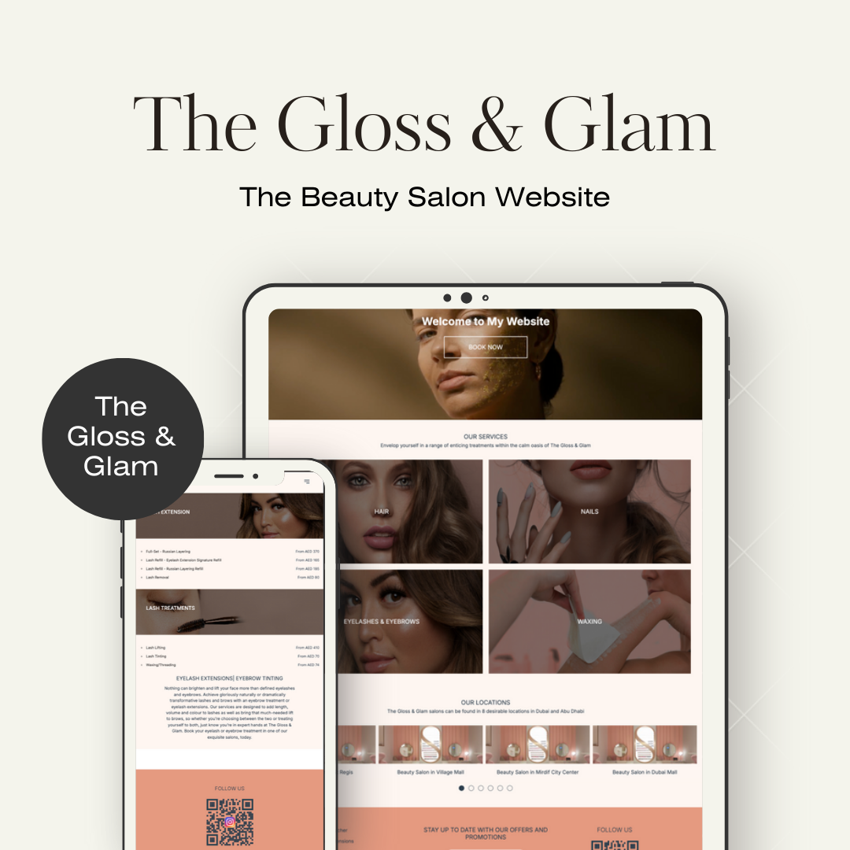

img 1

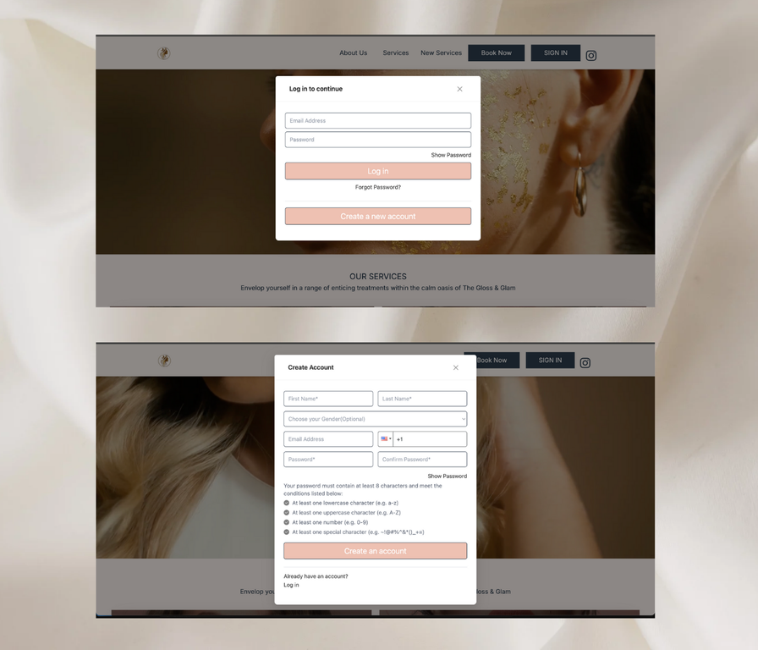
img2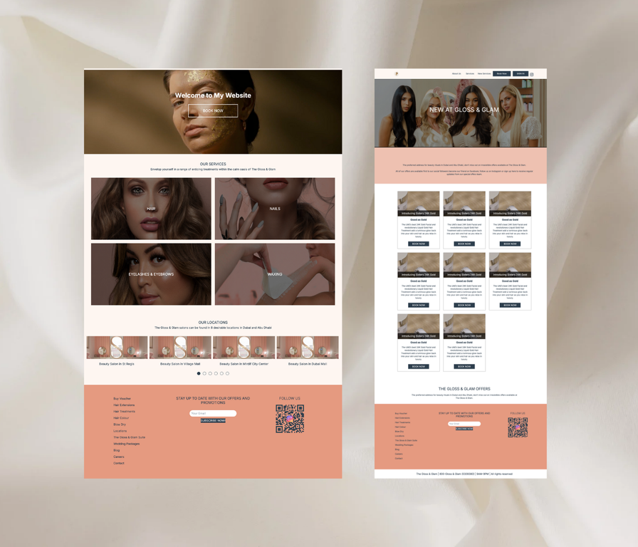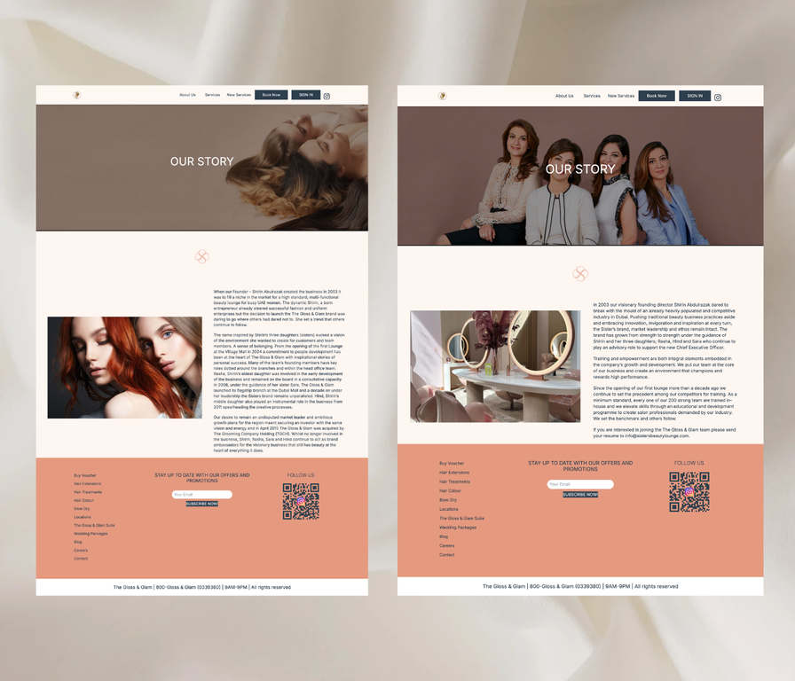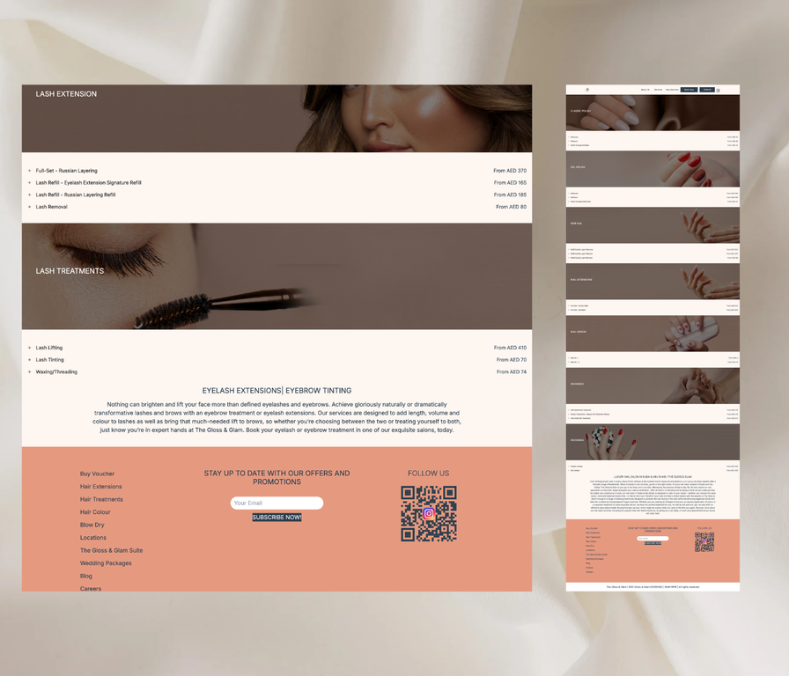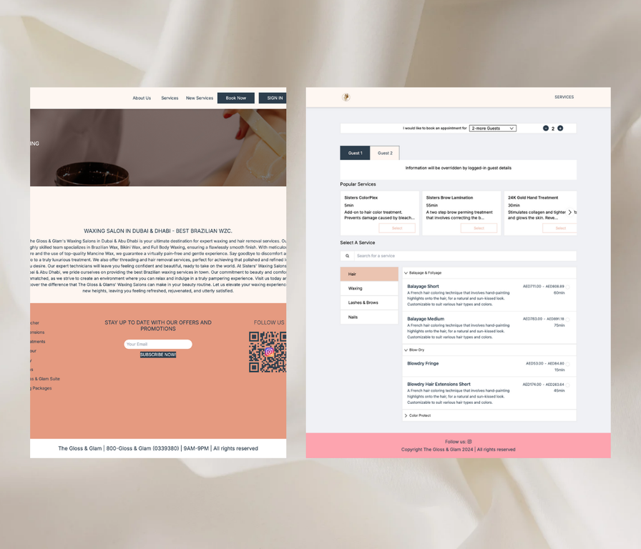

🎓 Introduction
In the world of beauty and wellness, having a strong digital presence is crucial for attracting and retaining clients. Understanding this need, we created a modern and elegant website for The Gloss & Glam Beauty Salon, allowing customers to browse services, explore the salon’s story, and easily book appointments. This case study outlines the challenges, solutions, and outcomes of building a high-end beauty platform using Next.js, Tailwind CSS, and Ant Design.

👩‍💼 Client Overview
Our client, The Gloss & Glam Beauty Salon, is a luxury beauty destination that offers a wide range of services, including hair styling, skincare, and spa treatments. The salon's goal was to create a website that not only reflected the sophistication and elegance of their brand but also provided a seamless booking experience for their clients.

🎯 Project Goals
- 📱 Responsive Design: Ensure the platform is accessible and visually stunning on all devices, from smartphones to large desktops.
- 💇‍♀️ Service Showcase: Create an appealing display of services with rich details and pricing information.
- 🗓️ Appointment Booking: Implement an easy-to-use system for booking appointments with available stylists.
- 👤 User Management: Offer user registration and login functionality for personalized booking experiences.
- 💎 Salon Story: Highlight the salon’s luxurious atmosphere with dedicated pages for "About Us" and "The Founder."

🛠️ Technology Stack
- Frontend: Next.js, React, Tailwind CSS
- UI Components: Ant Design
- Styling: Tailwind CSS for custom responsive layouts
- Hosting: Vercel for optimal performance and SEO

📈 Development Process

1. 📝 Planning and Requirements Gathering
We worked closely with the client to understand their brand identity and requirements. The focus was on creating a user-friendly site that offered rich visuals and a smooth booking process. Key features such as service listings, stylist profiles, and appointment scheduling were defined.

2. 🎨 Design and Prototyping
The design team crafted high-fidelity mockups using Figma, focusing on a modern, clean aesthetic that reflects the luxurious feel of the salon. Feedback was incorporated into multiple iterations, ensuring the design aligned with the brand’s identity.

3. 💻 Frontend Development
Leveraging Next.js for its server-side rendering capabilities, we built a highly performant website that enhances SEO and load times. Tailwind CSS allowed for quick prototyping of the responsive layout, while Ant Design components ensured a polished, cohesive UI.
Key Features Implemented:
- 📅 Service Booking System: Customers can browse and book services by selecting from a list of available professionals and time slots.
- 📱 Responsive Design: A mobile-first approach ensures smooth navigation and browsing across all devices.
- 👤 User Profiles: Registered users can manage their bookings and preferences.

4. 📊 Testing and Quality Assurance
Thorough testing was conducted using Jest and Cypress to ensure all components worked seamlessly across different devices and browsers. User acceptance testing (UAT) with the client ensured that the final product met their expectations.

5. 🚀 Deployment
The website was deployed on Vercel, taking full advantage of its optimized hosting for Next.js applications. This deployment ensured fast load times, global distribution, and automatic scaling for increased traffic during peak hours.

2-Home Style Furniture Shop

My role. Full Stack Developer
Project description. Home Style is a modern, visually stunning furniture website displaying a wide range of pieces. Built with React, styled using Tailwind CSS, and animated with AOS, it ensures an elegant user experience. Visitors can easily browse categories with smooth animations highlighting each item as they scroll.

The site features an Add to Cart function powered by JavaScript for real-time updates, ensuring a seamless shopping experience. Home Style offers an intuitive, dynamic, and responsive interface, helping users find and purchase the perfect furniture effortlessly.
Skills and deliverables
Tailwind CSS UI Animation ReactJ avaScript
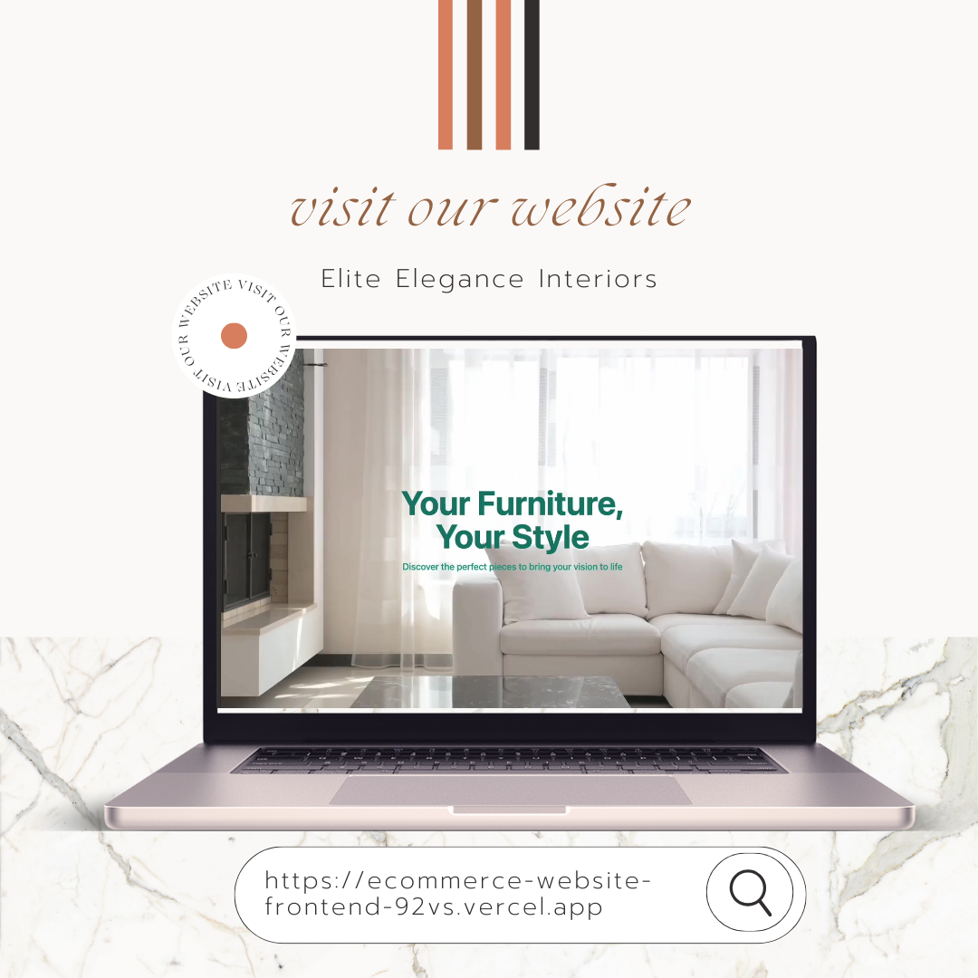
🎓 Introduction
In the fast-evolving world of e-commerce, standing out in the crowded furniture market requires more than just a beautiful website; it demands a seamless, engaging user experience. Home Style, our latest project, is a e-commerce platform that combines modern design with advanced technology to offer an exceptional online shopping experience. Leveraging React, Tailwind CSS, and AOS for animations, Home Style is crafted to make browsing and purchasing furniture an effortless and delightful journey.
👨‍💼 Client Overview
Home Style is dedicated to bringing high-quality, stylish furniture to consumers looking to enhance their living spaces. Their vision was to create a visually stunning and highly functional online store that not only showcases a diverse range of furniture but also provides an intuitive shopping experience. The platform needed to be as elegant and functional as the furniture it sells, with a focus on user experience and real-time functionality.
🎯 Project Goals
🛋️ Visual Appeal: Design a modern, visually engaging website that highlights the beauty of each furniture piece.
🔄 Real-Time Interaction: Implement a responsive and dynamic shopping experience with real-time updates.
📱 Responsive Design: Ensure the website performs seamlessly across all devices and screen sizes.
🔍 Easy Navigation: Provide a user-friendly interface that allows visitors to browse categories and find products effortlessly.
💬 Smooth Animations: Integrate animations to enhance the visual appeal and user engagement as visitors interact with the site.
🛠️ Technology Stack
- Frontend: React for a dynamic, interactive user interface
- Styling: Tailwind CSS for a modern, responsive design
- Animations: AOS (Animate On Scroll) for smooth, engaging animations
- Real-Time Updates: JavaScript for dynamic functionality and real-time cart updates
📈 Development Process
- 📝 Planning and Requirements Gathering
We started by collaborating with Home Style to understand their vision and requirements. The focus was on designing a visually stunning site that would showcase their furniture effectively while offering a seamless user experience. Key features included category browsing, real-time cart updates, and smooth animations.
- 🎨 Design and Prototyping
Our design team used Figma to create wireframes and prototypes of the website. The goal was to develop an elegant interface that would highlight each furniture piece while ensuring an intuitive user experience. The design was refined based on feedback to achieve a visually appealing and functional end product.
- 💻 Frontend Development
React was used to build a dynamic and interactive user interface. Tailwind CSS was employed to create a modern and responsive design, ensuring the site looked great on all devices. AOS was integrated to provide smooth animations that enhance user engagement and showcase furniture pieces effectively.
Key Features Implemented:
🔄 Add to Cart Functionality: Real-time updates to the cart using JavaScript, ensuring a seamless shopping experience.
🛒 Dynamic Product Display: Smooth animations that highlight products as users scroll through products.
📱 Responsive Layout: A design that adapts seamlessly to various screen sizes, providing a consistent experience across devices.
- 🧪 Testing and Quality Assurance
We conducted thorough testing to ensure the website was both functional and visually appealing. This included unit testing for individual components and end-to-end testing to ensure the overall user experience was smooth. User acceptance testing (UAT) was performed to gather feedback and make final adjustments.
- 🚀 Deployment
Home Style was deployed using modern hosting solutions that ensure reliability and performance. Continuous Integration and Continuous Deployment (CI/CD) pipelines were established to facilitate smooth updates and maintenance.
🛡️ Challenges and Solutions
⚡ Real-Time Functionality: Implementing real-time cart updates posed a challenge. We addressed this with efficient JavaScript solutions to ensure the cart updates seamlessly as users add or remove items.
🌐 Performance Optimization: Ensured the site loads quickly and performs well across different devices by optimizing images and leveraging Tailwind CSS for efficient styling.
🎨 Animation Integration: Smoothly integrating AOS animations required careful tuning to ensure they enhanced the user experience without causing performance issues.
🏆 Conclusion
The Home Style project successfully delivered a modern, visually stunning furniture e-commerce platform that enhances the online shopping experience. By combining React, Tailwind CSS, and AOS animations, we created a site that is both elegant and functional, meeting the high standards set by Home Style.
🔮 Future Plans
Home Style plans to enhance the platform further by integrating features such as personalized recommendations, augmented reality (AR) for visualizing furniture in users' homes, and advanced search functionalities to improve the shopping experience. The goal is to continually innovate and provide a top-notch online shopping experience for furniture enthusiasts.

3-Food Delivery Mobile App

My role. Frontend Developer

Project description:The food delivery mobile app, developed with React Native, provides a convenient platform for users to order meals from their favorite restaurants.

Utilising Redux for managing the cart functionality, the app ensures seamless state management for adding, removing cart items.Styled Components and NativeWind create a responsive and visually appealing interface.

Customers can browse menus, customise orders, and manage their cart with real-time updates, making the entire food ordering process quick, intuitive, and hassle-free.

Skills and deliverables
ReactNative nativewind Redux
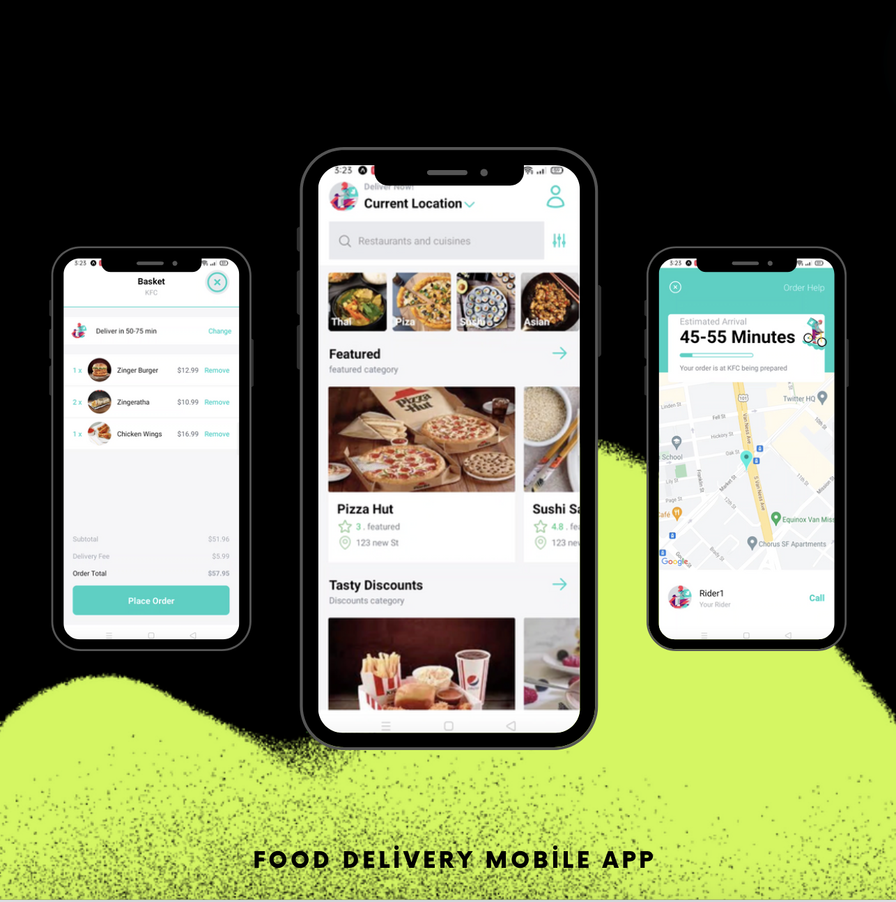
Another option
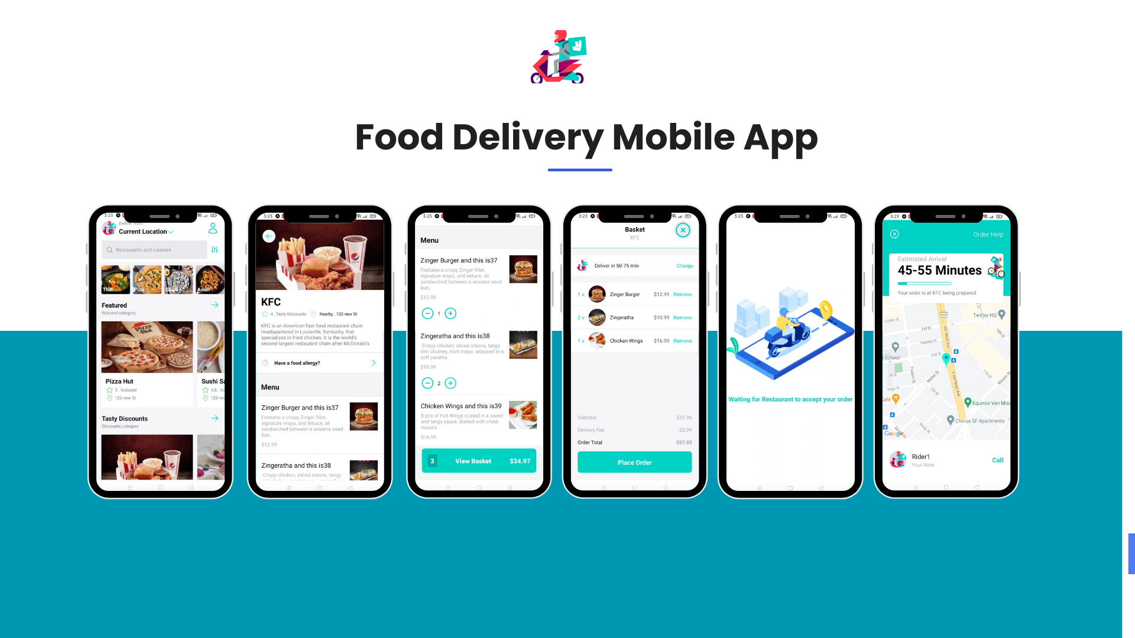

🎓 Introduction
In the fast-paced world of food delivery, we aimed to create a mobile app that provides users with a seamless experience to browse, customize, and order from their favorite restaurants. This case study details the process, challenges, and outcomes of developing the app using React Native.
🎯 Project Goals
📱 User-Friendly Interface: Design an intuitive UI for browsing and customizing orders.
🔄 Cart Management: Enable real-time cart updates and item tracking.
🚀 Performance Optimization: Ensure smooth, responsive interactions, even with high traffic.
🛠️ Technology Stack
- Frontend: React Native for cross-platform development
- State Management: Redux for handling cart functionality
- Styling: Styled Components and NativeWind for a clean, responsive interface
📈 Development Process
- 📝 Planning and Requirements Gathering
We collaborated with client to outline key features like menu browsing, cart management, and restaurant profiles. User feedback was collected to enhance functionality.
- 🎨 Design and Prototyping
Our designers crafted mockups using Figma, focusing on simplicity and easy navigation. The design was refined based on user testing to ensure a smooth experience.
- 💻 Frontend Development
React Native was chosen for its cross-platform capabilities. Redux was used to ensure robust cart functionality, allowing users to add, remove, and update items seamlessly.
Key Features Implemented:
🍽️ Dynamic Menus: Real-time restaurant updates.
🛒 Cart Functionality: Instant feedback when adding or removing items.
- 🧪 Testing and Quality Assurance
Unit and integration testing were conducted to ensure smooth performance across iOS and Android platforms. User acceptance testing (UAT) validated the design and functionality.
🛡️ Challenges and Solutions
🔄 Real-Time Cart Management: Redux was optimized for real-time state updates, ensuring smooth user interactions.
⚡ Performance: Lazy loading was implemented to handle high traffic during peak hours.
🏆 Conclusion
This food delivery app offers a smooth, scalable, and user-friendly solution, bringing local eateries to customers’ fingertips.
🔮 Future Plans
Enhance delivery tracking and integrate payment gateways to offer a more comprehensive service.

3-CarSupportGuys (Car Services App)

My role. Frontend Developer

CarSupportGuys is an innovative car service website designed to offer seamless support for all your vehicle needs. Built with cutting-edge technologies like Nuxt, Vue, the platform ensures a smooth user experience. Whether it's electrical, transmission, battery, or cooling issues, users can connect with expert mechanics via chat or call for immediate assistance.

To start, users simply enter their car and the miles it has run before discussing the problem.CarSupportGuys offers expert care customized for your car.

Skills and deliverables
- Nuxt.js Vue.js Responsive Design

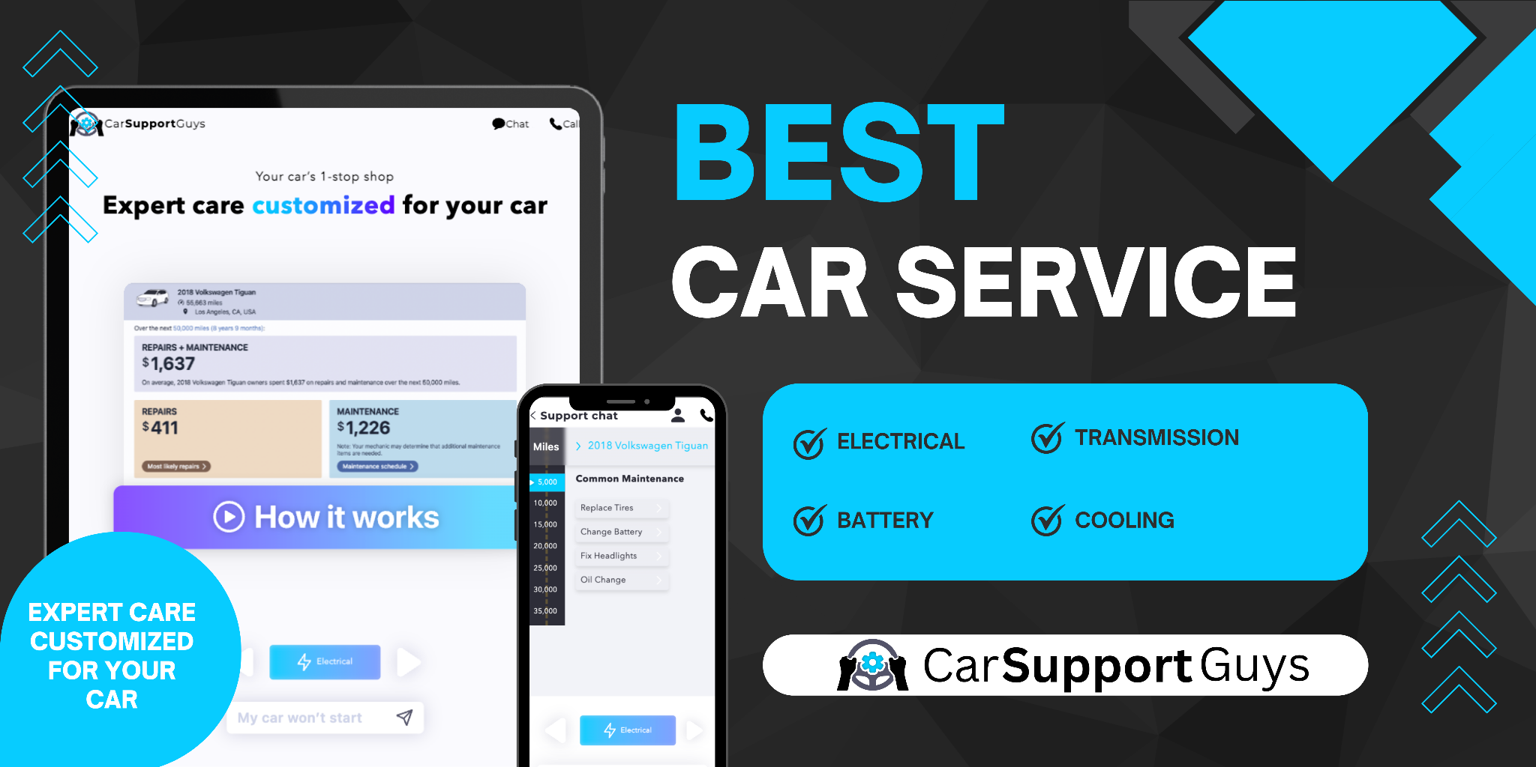
Further Description:
🎓 Introduction
CarSupportGuys is a comprehensive car service platform designed to provide users with real-time support for their vehicle-related issues. Whether it’s electrical malfunctions, transmission problems, battery failures, or cooling system concerns, this app ensures users get expert guidance from professional mechanics. With the rise of digital platforms offering on-demand services, CarSupportGuys is dedicated to offering convenient, expert car care, making it the go-to solution for car owners.
👨‍💼 Client Overview
CarSupportGuys aims to bridge the gap between car owners and expert mechanics by providing a platform that connects users with certified professionals. The service eliminates the need to visit a repair shop for minor issues and helps users get immediate assistance via chat or phone calls. Their focus is on providing expert, personalized care for each user’s car, ensuring all issues are handled promptly and effectively.
🎯 Project Goals
🚗 Real-Time Mechanic Assistance: Offer users the ability to connect with mechanics through chat or call for troubleshooting car issues.
🔧 Custom Solutions for Each Vehicle: Provide tailored advice based on the car’s condition, miles driven, and type of issue.
📈 User-Friendly Interface: Ensure the platform is easy to use and accessible for all car owners, regardless of technical expertise.
🌐 Wide Range of Services: Cover multiple areas of car support including electrical, transmission, battery, and cooling issues.
🛠️ Technology Stack
- Frontend: Nuxt and Vue for a smooth, responsive interface
- State Management: Formik and Yup for handling user input and validation
- Carousel Features: Swiper and Nuxt-Swiper for showcasing key services and features in a sleek, interactive way
- Icons and UI Enhancements: React Icons for providing visual cues and making the UI more intuitive
- SSR (Server-Side Rendering): Vue-server-renderer for enhanced performance and SEO, ensuring the website loads efficiently across all devices
📈 Development Process
- 📝 Planning and Requirements Gathering
We began by gathering detailed requirements from CarSupportGuys to understand their vision and the needs of their target audience. The focus was on providing expert car support in real-time while maintaining ease of use for customers.
- 🎨 Design and Prototyping
Our design team created a modern, clean interface using Figma, focusing on delivering a user experience that allows customers to quickly and easily request help for their car issues. The design was optimized for responsiveness to ensure accessibility across mobile, tablet, and desktop.
- 💻 Frontend Development
We developed the frontend using Nuxt and Vue, leveraging their capabilities to create a highly responsive, interactive, and dynamic platform. The use of Formik and Yup for handling input validation ensured users could submit relevant information.
Key Features Implemented:
🔧 Real-Time Communication: Users can connect with mechanics instantly via chat or call to troubleshoot issues.
🚗 Mileage Tracking: Before seeking advice, users enter the miles driven to help mechanics provide more accurate support.
📊 Dynamic Swipers: Swiper and Nuxt-Swiper were used to create a carousel for key services, offering a sleek way to navigate through available options.
- 🧪 Testing and Quality Assurance
Comprehensive testing was performed to ensure the platform was fully functional across various devices and scenarios.
- 🚀 Deployment
CarSupportGuys was deployed using a robust infrastructure to support growing traffic and service requests. With efficient SSR implementation, the platform was successfully launched to provide real-time car support.
🛡️ Challenges and Solutions
⚡ Performance Optimization: Server-side rendering with Vue-server-renderer ensured the platform remained fast and responsive, even under heavy traffic. This was critical for users relying on the platform in urgent car related situations.
🏆 Conclusion
CarSupportGuys successfully offers a one-stop shop for car owners to receive expert, real-time assistance from mechanics. The app’s user-friendly design, and real-time communication features make it a game-changing platform for vehicle support. With comprehensive services, users can address any car issue without needing to visit a repair shop for diagnosis.
🔮 Future Plans
CarSupportGuys plans to add additional services like maintenance scheduling and service reminders. The app is also looking into integrating AI-driven diagnostics for quicker problem identification, further streamlining the car repair process for users. The platform will continue evolving to provide even more personalized, expert care for all car owners.

